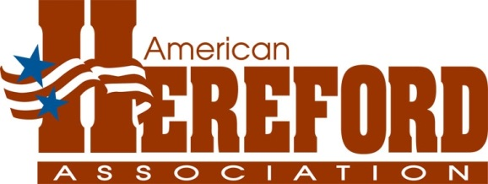

# FOR IMMEDIATE RELEASE

Contact: Joe Rickabaugh, jrick@hereford.org or 816-842-3757

Jan. 24, 2014

Mile High Night Hereford Sale Grosses $1.1 Million

**KANSAS CITY, Mo. ­­­—** In the second year in its new venue, the Mile High Night Hereford Sale upped the ante again. The sale is a highlight of the National Western Stock Show (NWSS) in Denver. This year it was Jan. 17 once again on the stadium floor. The sale continues to astonish, as this was the second year in a row the gross sales nearly doubled. The crowd was record-setting with some saying it was the largest crowd they’d ever seen at a cattle sale. An estimated 5,000 people were in attendance.

They came to see a show and that’s just what they got. The Hereford offering, as always, was elite, and the bidding proved it. When Eddie Sims, National Cattle Services Inc., silenced the gavel for the final time, $1,106,650 had been spent. The bull average was up $8,000 to $55,043, and 31.5 females commanded $15,749 per head, which is more than $5,000 above last year’s average. The average on five flushes was $10,550, which jumped 63% over last year’s amount. And the average price of embryos more than tripled, with 12 embryos bringing a whopping $3,000 average.

Breaking down the sale, American Hereford Association Director of Seedstock Marketing Joe Rickabaugh says, “The Hereford momentum is exciting with 34 out of 55 lots bringing $10,000 or more. The last lot in the sale brought $10,000, and there were 11 lots over $30,000.”

Topping the sale at $110,000 was Lot 15, consigned by Kolt Cattle Co., Seward, Neb. She is an April 2013 daughter of Golden Oak Outcross 18U and out of the phenomenal cow R Sweet Red Wine 039. Knapper Cattle Co., Kingman, Ind., took home this amazing prospect.

The second high seller was Lot 13, a quarter semen interest on Churchill Stud 3134A. He is a Jan. 30, 2013, son of KJ HVH 33N Redeem 485T ET and out of Churchill Lady 002X ET. Harrison Cattle Co., Arapahoe, Okla., and the Stud Syndicate, Manhattan, Mont., paid $100,000 for the quarter semen interest in this impressive young bull prospect from Churchill Cattle Co., Manhattan, Mont.

The sale didn’t drop off much, as the third high seller commanded $82,500. Lot 22, a half-interest in Chez Strawberry Wine ET 204Z, another daughter of R Sweet Red Wine 039, is a Sept. 2012 calf by CRR About Time 743. She was consigned by Trent Ray, Abingdon, Ill., who showed her to the Reserve Champion Polled Female title at the NWSS and the 2013 Junior National Hereford Expo Reserve Grand Champion Polled Female title. Kolt Cattle, Seward, Neb.; Dylan Evans, Lebo, Kan.; and Hirschfield Farms, Benedict, Neb., were the top bidders on the half-interest in this superb heifer.

Eddie and Ruth Sims of National Cattle Services have managed the Mile High Sale for the past 12 years. Rickabaugh says, “They have brought this sale out of the dust to the level of envy among all breeds in Denver. A big thank you goes to both of them as they retire as sale managers.”

For more information about the sale, contact Rickabaugh at 816-842-3757 or jrick@hereford.org.

####

The American Hereford Association, with headquarters in Kansas City, Mo., is one of the largest U.S. beef breed associations. The not-for-profit organization along with its subsidiaries, Certified Hereford Beef (CHB) LLC, Hereford Publications Inc. (HPI), and American Beef Records Association (ABRA), provide programs and services for its members and their customers, while promoting the Hereford breed and supporting education, youth and research. For more information about the Association, visit Hereford.org.